**Task List For MAC work**

AEGIS Cable Plant Service

**Bldg. 36, 1ET1 Cabling Demo**

**WO415466**

**Johnson Space Center**

**Date:**

**August 1, 2022**

**Project:**

Customer Name: Leidos|AEGIS

Customer Address: 2101 NASA Road 1

Houston, Tx 77058

Customer Contact: David j Abraham

Customer E-mail Address: David.j.abraham@nasa.gov

Project Due Date: August 8, 2022

**Abbreviations**

AEGIS – Advanced Enterprise Global Information Technology Solutions

AHJ – Authority Having Jurisdiction

ANSI – American National Standard Institute

BICSI – Building Industry Consulting Services International

CSM – Customers Service Manager

DCE – Data Communications Engineer

HASP – Health And Safety Plan

JHA – Job Hazards Analysis

JSC – Johnson Space Center

LAN – Local Area Network

N/A – Not Applicable

NASA – National Aeronautics and Space Administration

NEC – National Electrical Code

NESC – National Electrical Safety Code

OSHA – Occupational Safety and Health Administration

OSPDRM – Outside Plant Design Reference Manual

PM – Project Manager

PPE – Personal Protective Equipment

RCDD – Registered Communications Distribution Designer

RFQ – Request For Quotation

ROM – Rough Order of Magnitude

RU – Rack unit

SCH – single cassettes housing

TBD – To Be Decided

TO/WO – Telecommunications Outlet/ Work Outlet

TDMM – Telecommunications Distribution Methods Manual

**I. Customer Requirements:**

* + Trace and demo all Amphenol cables in 1ET1.
    - Amphenol cables are going into the 4” penetration in 1ET1, they will need to be traced out and demoed.

**II. Scope of MAC Work:**

* + Refer to the drawings below.
  + Make sure to leave a clean area at the end of each workday and at the finish of the project.

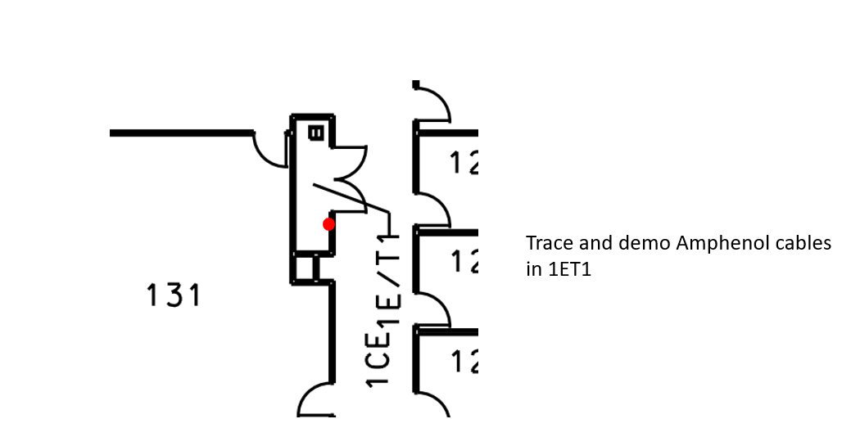

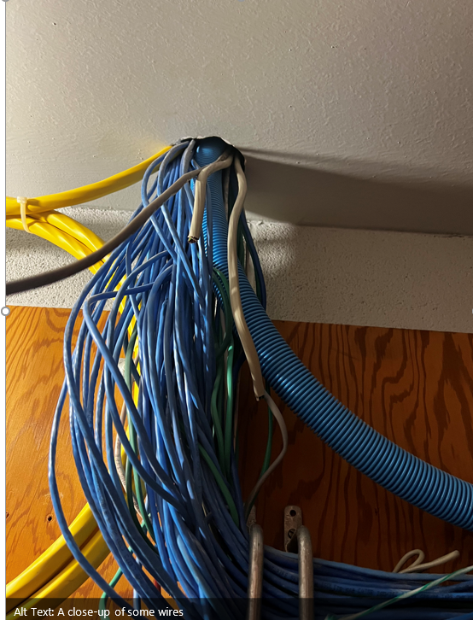

**Note:**

**Safety inspection: All tools and equipment shall be inspected to meet manufacture operating standards prior to start this project.**

* Make sure to leave a clean area at the end of each workday and at the finish of the project.

**III. Out of Scope:**

* Define any work to be performed by others and not AEGIS or AEGIS sub-contractor (N/A if not applicable)

**IV. Basis of Construction**:

The basis of construction for materials, means, and methods for the installation of structured cabling systems at NASA Johnson Space Center (Houston, Texas) Voice and Data Communications Systems Cabling Infrastructure Standards.

This document contains information regarding the quality of installations, submittals, close-out deliverables; and shall be referenced to validate proper materials and methods of installation in the performance of the installation of a cabling system.

**V. Contractor Responsibilities**

1. All certifications and/or licenses are in place.
2. Any required safety classes are the responsibility of the Contractor.
3. Contractor will provide testing of all cabling systems that are installed as part of the scope. This is to be performed using the proper test equipment provided by the contractor via qualified and properly trained personnel.
4. The contractor shall provide support personnel to the extent requested by LEIDOS to work under LEIDOS direction in support of the Advanced Enterprise Global Information Technology Solutions (AEGIS) contract at the NASA Johnson Space Center (Houston, Texas). The majority of this support will be applied in the area of infrastructure upgrade task fulfillment of inside cable plant as needed and appropriate to the capabilities of the company. In the performance of this effort, the contractor shall provide qualified and experienced personnel. Each task order will contain specific work project statements; which may include Infrastructure upgrades varying in scope and duration and can range from a single cable installation to major renovations/new construction buildout of a full Structured Cabling System.
5. The contractor will verify all pathways for cable installations.
6. The contractor shall assign a full time Project Manager (PM) who has full authority to act for the contractor in all related matters. The PM shall be the primary point of contact to the AEGIS Customer Service Manager (CSM) and Data Communications Engineer (DCE).
7. The contractor shall be responsible for cost, schedule, and technical performance under this subcontract. The contractor shall perform no work and no payment for services will be rendered without prior LEIDOS authorization.
8. Contractor is to provide as-built drawings for all work that is completed.

**VI. Place Of Performance**

The contractors tasks shall be primarily performed at the NASA Jphnson Space Center (JSC):

2101 NASA Road 1

Houston, Tx 77058

Work is to be completed during normal business hours of 7:30 AM – 4:30 PM M-F in 8 hour shifts.

**VII. Workmanship**

1. All Materials shall be installed in compliance with the recommendations of the respective manufacturer, current industry standards, these Specifications and the NASA JSC Cabling Infrastructure Standards, the National Electrical Code, all applicable state and local building and fire codes, and best practices.
2. All work shall conform to the requirements of the Specifications. The installation, construction, cable terminations, and splicing shall be performed by workers trained and skilled in this type of work.
3. Contractor shall meet all OSHA and NASA requirements related to safety and equipment operation. Work shall be performed during normal, day shift working hours, except when other options are specified.
4. Contractor shall be responsible for repairing all building and inside cable plant faults, due to Contractor’s installation defects, poor workmanship, and/or negligence, at no additional cost to NASA prior to acceptance of the Work. NASA personnel and/or agents shall have free access to the work at all times
5. During the course of the work if the contractor has suggestions to provide a better design or installation the contractor should present these suggestions in a timely manner to the CSM or DCE.

**VIII. Applicable Standards**

All infrastructure design and construction shall conform to current industry standards, federal, state, and local codes. The following documents form a part of, and are applicable to these specifications and those task orders issued under this contract. Where an effective date is not shown for any given document or publication, the issue in effect on the effective date a project is awarded shall apply. Any expressed conflict in documents shall be resolved by the LEIDOS AEGIS representative.

A. **NFPA 70**, National Electrical Code (NEC).

B. **ANSI C2**, National Electrical Safety Code (NESC).

C. **ANSI/TIA-568-C Set,** Includes all addendums and subsets.

D. **ANSI/TIA-568-C.0**, Generic Telecommunications Cabling for Customer Premises (February 2009)

E. **ANSI/TIA-568-C.0-1**, Generic Telecommunications Cabling for Customer Premises – Addendum 1, Updated References for Balanced Twisted-Pair (Sept. 2010)

F. **ANSI/TIA-568-C.1**, Commercial Building Telecommunications Cabling Standard (February 2009)

G. **ANSI/TIA-568-C.1-1**, Commercial Building Communications Cabling Standard – Addendum 1, Pathways and Spaces (May 2012)

H. **ANSI/TIA-568-C.1-2**, Commercial Building Telecommunications Cabling Standard – Addendum 2, General Updates (November 2011)

I. **ANSI/TIA-568-C.2**, Balanced Twisted-Pair Telecommunications Cabling and Components Standards (August 2009)

J. **ANSI/TIA-568-C.3-1**, Optical Fiber Cabling Components Standard (June 2008)

K. **ANSI/TIA-568-C.3-1**, Optical Fiber Cabling Components Standard – Addendum 1, Addition of OM4 Cabled Optical Fiber and Array Connectivity (December 2011)

L. **ANSI/TIA-568-C.4**, Broadband Coaxial Cabling and Components Standard (July 2011)

M. **ANSI/TIA-569-C**, Telecommunications Pathways and Spaces, including all TSBs and addenda (May 2012).

N. **ANSI/TIA-606-B**, Administration Standard for Telecommunications Infrastructure (June 2012)

O. **ANSI/TIA-607-B**, Telecommunications Bonding and Grounding (Earthing) for Customer Premises. (Sept. 2011)

P. **ANSI/TIA-758-B**, Customer Owned Outside Plant Telecommunications Infrastructure Standard. (March 2012)

Q. **ANSI/TIA-942-A**, Telecommunications Infrastructure for Data Centers. (August 2012)

R. **BICSI** Telecommunications Distribution Methods Manual (TDMM) 13th Edition.

S. **BICSI** Outside Plant Design Reference Manual (OSPDRM) 5th Edition.

T. **ANSI/NECA/BICSI 568-2006,** Standard for Installing Commercial Building Telecommunications Cabling. (2006)

**IX. Verification of Details**

1. Contractor shall become familiar with details of work in the field and shall advise LEIDOS in writing of any discrepancy in the SOW prior to commencement of Work.
2. Contractor shall acknowledge that it has investigated and satisfied itself as to all of the conditions affecting the Work. Any failure by Contractor to become acquainted with the available information shall not relieve Contractor from responsibility for estimating properly, the difficulty or cost of successfully performing the requested Work. LEIDOS shall assume no responsibility for any erroneous conclusions or misinterpretations made by Contractor based on information made available by LEIDOS
3. Contractor shall be responsible to verify quantities for all equipment, cabling, components, and materials prior to start of work Contractor shall accept full responsibility for accurately estimating the Work and Materials based on the Specifications and Drawings.

**X. Labor and materials**

1. Contractor shall provide and pay for labor, equipment, tools, test equipment, construction equipment and machinery, transportation, and other services necessary for the proper execution and completion of the Work.
2. Contractor shall enforce strict discipline and order among Contractor’s employees and Subcontractors in performance of the Work.

**XI. Safety**

1. Contractor shall adhere to the latest edition of the American National Standard Institute (ANSI) National Electrical Safety Code (NESC), NASA & OSHA Standards, and all local fire and safety regulations.
2. The contractor shall adhere to the NASA Confined Space Program. All employees working on identified confined space projects shall be NASA Confined Space trained or authorized by NASA Safety personnel.
3. The contractor shall be required to perform a job hazards analysis (JHA) and provide a Health and Safety Plan (HASP) that shall be approved by NASA prior to the commencement of work. All employees are required to sign the JHA and HASP indicating they have read, understand, and will follow the safety procedures outlined in the JHA & HASP.
4. NASA reserves the right to inspect Contractor's work at any time to ensure compliance with the aforementioned documents and specific safety procedures stated herein.
5. Contractor shall be responsible to follow all safety requirements, conditions, and procedures as set forth at the NASA Johnson Space Center, JSC.
6. Contractor shall properly firestop all rated penetrations in accordance with NASA’s Safety, Health & Environmental Division, and the Facilities Division Authority Having Jurisdiction (AHJ).

**XII. Protection of persons and property**

1. The use of Personal Protective Equipment (PPE) is mandatory on all work at NASA Johnson Space Center, JSC. At a minimum, this PPE includes steel toed shoes, class 2 safety vest, hardhat, and safety glasses.
2. Contractor shall be responsible to provide all safety equipment and for the enforcement of all safety requirements including, but not limited to, use of hard hats, safety glasses, hearing protection, safety belts, tool tethers while working overhead, safety cones, and preventing personnel from working overhead while others are working underneath.
3. Contractor shall provide protection of persons and property throughout the progress of the Work. Contractor shall provide the necessary safety equipment, barricades, and signs to protect personnel and property, of their own, their employees, contractor’s employees, and other trades working on the Site.
4. Contractor agrees to exercise reasonable care to avoid damage to NASA facilities and property of others. Contractor shall assume full responsibility for all damages to such facilities arising out of or caused by contractor. Contractor shall make an immediate report of all occurrences of any such damage and hereby agrees to repair or replace at Contractor's expense the necessary repairs or replacements.

**XIII. Cleaning**

1. In performance of the Work, Contractor shall make every reasonable effort to protect floors, carpets, ceiling tiles, walls, and other property from damage, and shall restore all such property, subject to the Work, to conditions substantially the same as when Work began.
2. Contractor shall be responsible for daily cleanup and removal (within Contractor's work areas) of all non-salvageable materials and debris resulting from the execution of Work. Contractor shall be responsible for removal of materials and debris from Site. Oil waste, rags or flammable materials must be removed from the building immediately after use.
3. Contractor shall ensure that all work in finished areas of the building are cleaned and restored to the same conditions as before the Work. All salvageable materials not used or not yet installed shall be properly stored and secured.
4. Contractor shall clean equipment room racks, cabinets, and wall field equipment at conclusion of installation; removing all dust, debris, and garbage from the work site.

**XIV. Badges and parking permits**

1. Contractor agrees to abide by all of NASA’s parking and badging rules and guidelines. Contractor shall submit a list of personnel to LEIDOS prior to commencement of Work. LEIDOS shall work to provide the necessary access privileges as needed for the project or projects.
2. As part of the badging process, all Contractor personnel are subject to finger printing and criminal background checks.
3. Contractor shall be permitted to park in designated areas as determined by JSC regulations.

**XV. Responsibility for tools and equipment**

1. Contractor shall be responsible to supply, maintain, and secure all tools, ladders, test equipment, lift equipment and safety equipment. LEIDOS does not accept any responsibility for loss or theft.
2. **Contractor shall identify items that may have a long lead time.**